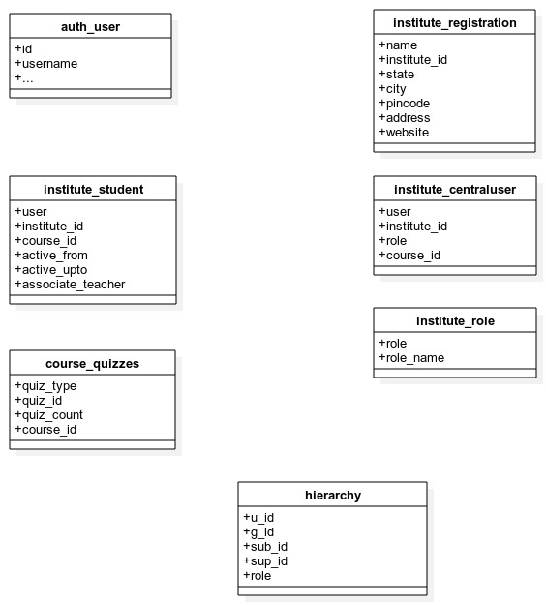

This relation indicates that the attribute is a foreign key to/ references the target attribute (pointed to by the diamond).

